

ACKNOWLEDGEMENT
Acknowledgements are not the full expression of once gratitude towards the person whose help is acknowledged, Though language is an inadequate medium to express one's gratitude. It is the one which can recall one's gratitude indebtedness to once benefactor. We thank the all mighty for showering his blessing to complete this project successfully.
We would like to extend our sincere gratitude to our highly esteemed and respected Principal, Dr. V. SUJATHA, M.Com., M.Phil., Ph.D., Cauvery College for Women (Autonomous), Tiruchirappalli for permitting us to do our project successfully.
We wish to extend our sincere thanks and deep appreciation to the exceptionally supportive Professor and Head, Dean of Science, Dr. V. SINTHU JANITA, MCA, M.Phil., Ph.D., PG & Research Department of Computer Science, for giving us an opportunity to pursue this project
We express our deep sense of gratitude and heartful thanks to our Head In-charge Ms. N. GIRUBAGARI, MCA., M.Phil., SET., Associate Professor, PG & Research Department of Computer Science, for paving the way towards attaining our cherished dream.
We humbly tender our most profound and heartfelt gratitude to our esteemed Project Guide Dr. A. SAHAYA JENITHA MCA., M.Phil., Ph.D., Associate Professor, PG & Research Department of Computer Science, for her valuable guidance to complete this project. Her sincere approach and all-time help were great inspiration and strength throughout this project
We extend our deepest thankfulness to our hardworking and compassionate Project In charge Ms. S. UDHAYA PRIYA, MCA., M.Phil., SET., Associate Professor, PG & Research Department of Computer Science, who spared her valuable time and effort to guide us in the completion of this project.
We also thank the other teaching, non-teaching staff and all our friends of this college for their support and encouragement to complete our project.
We would like to express our gratefulness to our parents for their support as well.

MULTIFACETED AUTHENTICATION AND DETECTION FRAMEWORK

ABSTRACT
The importance of ensuring the authenticity and reliability of digital images has grown significantly, primarily due to the ease of modifying such images with the progress of digital image editing tools. Consequently, there is a growing emphasis on the development of techniques for detecting image manipulation. One particular area of focus in digital image authentication is copy-move forgery detection. This project presents a survey and a comparative study on copy-move forgery detection techniques in face, databases, and evaluation metrics. The study aims to provide insights into the effectiveness of different methods in detecting copy-move forgeries. The Project discusses prominent detection techniques, including block-based, keypoint-based, transform domain, hybrid methods, deep learning, and CNN approaches. The findings highlight the strengths, weaknesses, and key similarities and differences among the approaches. This study contributes to the understanding of the state-of-the-art in copy-move forgery detection and provides guidance for future research in this field.

- INTRODUCTION

In today's digital age, the manipulation of images has become increasingly prevalent, raising concerns about the authenticity and integrity of digital content. Digital image forgery, also known as image manipulation or tampering, refers to the deliberate alteration of images to deceive viewers or convey false information. With the proliferation of sophisticated image editing tools and software, perpetrators can easily modify images to manipulate reality, spread misinformation, or discredit individuals and organizations. Digital image forgery encompasses various techniques, including but not limited to, copy-move forgery, splicing, retouching, and morphing, each posing unique challenges for detection and analysis.

One of the most common forms of digital image forgery is copy-move forgery, where a portion of an image is copied and pasted into another part of the same image or a different image altogether. This technique is often used to remove or duplicate objects within an image, creating the illusion of authenticity.
This research aims to address the challenges posed by digital image forgery by developing advanced techniques and algorithms for detecting and analyzing manipulated images. By leveraging state-of-the-art image processing, computer vision, and machine learning techniques, this research seeks to enhance the ability to identify and authenticate digital images, enabling more reliable and trustworthy visual content. Through a comprehensive investigation of various forms of digital image forgery and the development of innovative detection methods, this research aims to contribute to the advancement of digital forensics and image authentication, ultimately fostering trust and accountability in the digital media landscape.

DOMAIN INTRODUCTION
DEEP LEARNING
Deep learning attempts to mimic the human brain-albeit far from matching its ability enabling systems to cluster data and make predictions with incredible accuracy. Deep learning is a subset of machine learning, which is essentially a neural network with three or more layers. These neural networks attempt to simulate the behavior of the human brain albeit far from matching its ability allowing it to “learn” from large amounts of data. While a neural network with a single layer can still make approximate predictions, additional hidden layers can help to optimize and refine for accuracy. Deep learning drives many artificial intelligence (AI) applications and services that improve automation, performing analytical and physical tasks without human intervention.

TECHNOLOGIES IN DL
Deep learning, a subset of artificial intelligence (AI), has emerged as a transformative technology with vast applications across various industries. In this explanation, we delve into the technologies that underpin deep learning, exploring the key components, methodologies, and advancements driving its evolution.

NEURAL NETWORKS
Neural networks serve as the foundation of deep learning, mimicking the structure and function of the human brain's neural networks. These networks consist of interconnected layers of artificial neurons, each layer performing computations on input data and passing the results to subsequent layers. The depth of neural networks distinguishes deep learning from traditional machine learning methods, allowing for the extraction of high-level features and complex patterns from raw data.

- SYSTEM ANALYSIS

  - EXISTING SYSTEM
A novel incremental learning framework for face forgery detection, where we design an adapter-based incremental learning scheme combined with a confidence-based ensemble prediction mechanism. When confronted with new forgery methods, we incorporate small trainable adapter modules, which are retrained along with their corresponding classification layers, yielding a series of task-specific modules. Then we incorporate a confidence-based ensemble prediction mechanism to aggregate all predictions. Through comprehensive evaluations on multiple benchmark datasets (FF++, DFD, and Celeb-DF), our method successfully mitigates the catastrophic forgetting problem in a cost-effective manner and attains state-of-the-art performance in cross-dataset scenario.

DISADVANTAGES
- Limited Generalization
- Scalability
- Adaptability to New Forgery Methods
- Training Overhead
- Delay Time

  - PROPOSED SYSTEM

The proposed approach acknowledges the inherent challenges in detecting face forgeries, particularly when parts of an face image are copied from one source to another. Despite subtle changes that may occur during this process, which are often imperceptible to the human eye, Convolutional Neural Networks (CNNs) excel in identifying such alterations when analyzing manipulated images. By scrutinizing the differences between the original image and its compressed version, the forgery component becomes more apparent. Leveraging this distinction, a Deep Neural Network (DNN)-based model can be trained to effectively detect face forgery. Through this method, the model learns to discern patterns indicative of manipulation, enabling it to accurately identify instances of image tampering with a high degree of reliability and efficiency.
An essential aspect of the proposed approach lies in analyzing the disparity between the original image and its compressed version, as it accentuates the forgery component within the manipulated image. As faces undergo compression, certain artifacts and distortions emerge, particularly in regions where manipulation has occurred. These discrepancies serve as indicators of potential tampering, providing valuable cues for the development of detection mechanisms. Leveraging this insight, a Deep Neural Network (DNN)-based model can be trained to effectively identify instances of face forgery by discerning subtle alterations in pixel values, textures, and structural elements. By capitalizing on the inherent differences between original and manipulated images, the proposed approach offers a robust framework for detecting and combating image forgery in various contexts, including digital forensics, content authentication, and multimedia security.

ADVANTAGES
- Effective Detection of Subtle Alterations
- Automated Detection Process
- Potential for Generalization

3. SYSTEM REQUIREMENTS

3.1 HARDWARE REQUIREMENTS

    - Processors: Intel® Core™ i5 processor 4300M at 2.60 GHz,8 GB of DRAM
    - Disk space: 320 GB
    - Operating systems: Windows® 10

3.2 SOFTWARE REQUIREMENTS

    - Server Side : Python 3.7.4(64-bit)
    - Client Side : HTML, CSS, Bootstrap
    - IDE : Flask 1.1.1
    - Back end : MySQL 5.
    - Server : WampServer 2i
    - OS : Windows 10 64 –bit

3.3 SOFTWARE DESCRIPTION

Python
Python is a general-purpose interpreted, interactive, object-oriented, and high-level programming language. It was created by Guido van Rossum during 1985- 1990. Like Perl, Python source code is also available under the GNU General Public License (GPL). This tutorial gives enough understanding on Python programming language.
      - Machine Learning
      - GUI Applications (like Kivy, Tkinter etc.)
      - Web frameworks like Django (used by YouTube, Instagram, Dropbox)
      - Image processing (like OpenCV, Pillow)
      - Web scraping (like Scrapy, BeautifulSoup, Selenium)
      - Test frameworks

Tensor Flow
Tensor Flow is an end-to-end open-source platform for machine learning. It has a comprehensive, flexible ecosystem of tools, libraries, and community resources that lets researchers push the state- of-the-art in ML, and gives developers the ability to easily build and deploy ML-powered applications.

Keras
Keras is a deep learning API written in Python, running on top of the machine learning platform TensorFlow. It was developed with a focus on enabling fast experimentation.
- User-friendly API which makes it easy to quickly prototype deep learning models.
      - Built-in support for convolutional networks (for computer vision), recurrent networks (for sequence processing), and any combination of both.

Pandas
pandas is a Python package that provides fast, flexible, and expressive data structures designed to make working with "relational" or "labeled" data both easy and intuitive. It aims to be the fundamental high-level building block for doing practical, real world data analysis in Python. The panda’s library is built upon another library NumPy, which is oriented to efficiently working with arrays instead of the features of working on Data frames

NumPy
NumPy, which stands for Numerical Python, is a library consisting of multidimensional array objects and a collection of routines for processing those arrays. Using NumPy, mathematical and logical operations on arrays can be performed.

Matplotlib
Matplotlib is a comprehensive library for creating static, animated, and interactive visualizations in Python. Matplotlib makes easy things easy and hard things possible. It provides an object-oriented API for embedding plots into applications using general-purpose GUI toolkits like Tkinter. lay a prominent role in monitoring and controlling external devices.
Python helps us do this by using a smart technique called CNN, which is great at recognizing patterns in images. Python also has many helpful tools that make it easier to teach the computer and analyze the pictures.
MySQL
MySQL is a relational database management system based on the Structured Query Language, which is the popular language for accessing and managing the records in the database. MySQL is open-source and free software under the GNU license. These queries are: insert records, update records, delete records, select records, create tables, drop tables, etc.

Wamp Server
WampServer is a Windows web development environment. It allows you to create web applications. WAMP Server is a reliable web development software program that lets you create web apps with MYSQL database and PHP. Bootstrap 4 Bootstrap is a free and open-source tool collection for creating responsive websites and web applications.

4. SYSTEM DESIGN

4.1 SYSTEM ARCHITECTURE
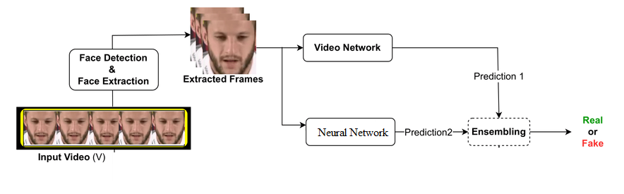4.2 DATA FLOW DIAGRAM
A data flow diagram (DFD) is a visual representation of how data flows through a system, showcasing the interactions between processes, data stores, and external entities. At its essence, a DFD comprises four primary elements: processes, data flows, data stores, and external entities. Processes symbolize the tasks or operations conducted within the system, encompassing activities such as data manipulation, computation, or transformation. Each process takes input data, performs specific actions, and generates output data.

Level 0
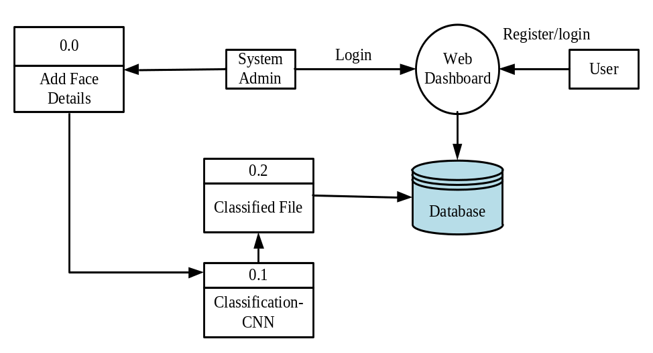

Level 1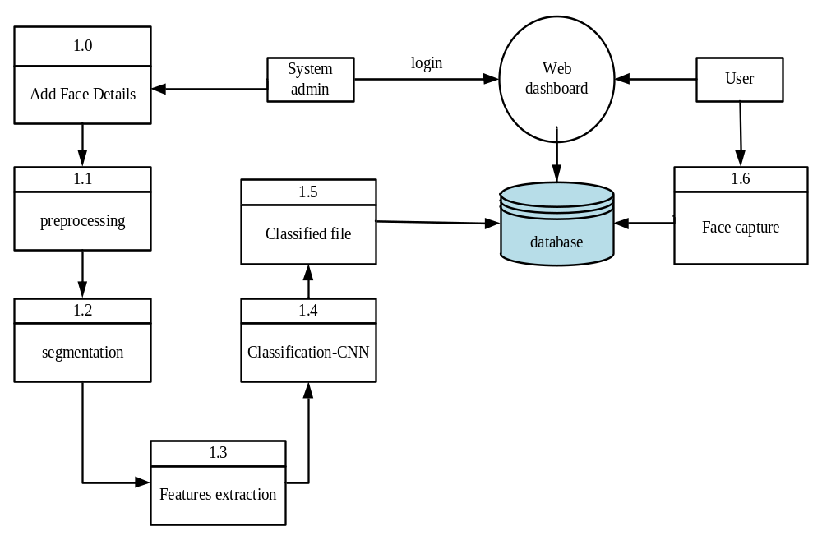
Level 2
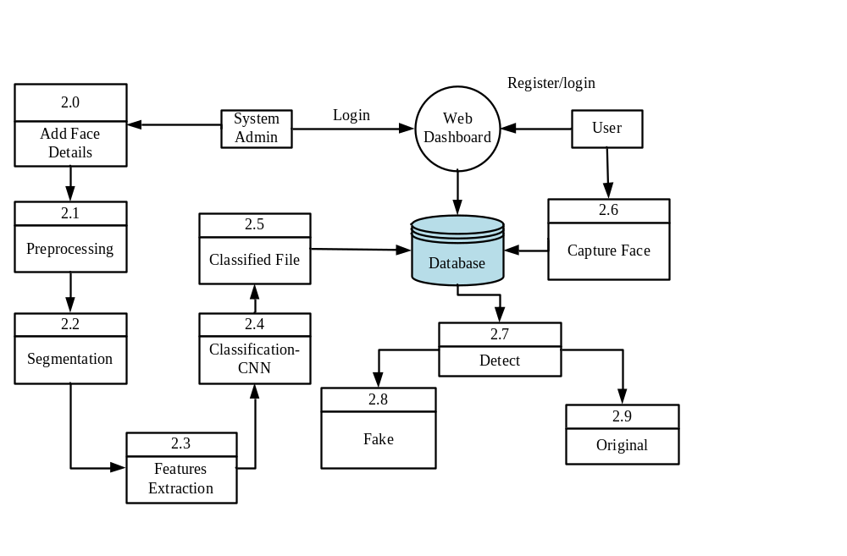

Class Diagram
A class diagram is a fundamental component of the Unified Modeling Language (UML) that visually represents the static structure of a system by illustrating the classes, attributes, relationships, and methods within that system. In a class diagram, classes are depicted as rectangles, with each class representing a blueprint for objects that share common attributes and behaviors. These attributes describe the characteristics of the objects, while methods represent the functions or operations they can perform.

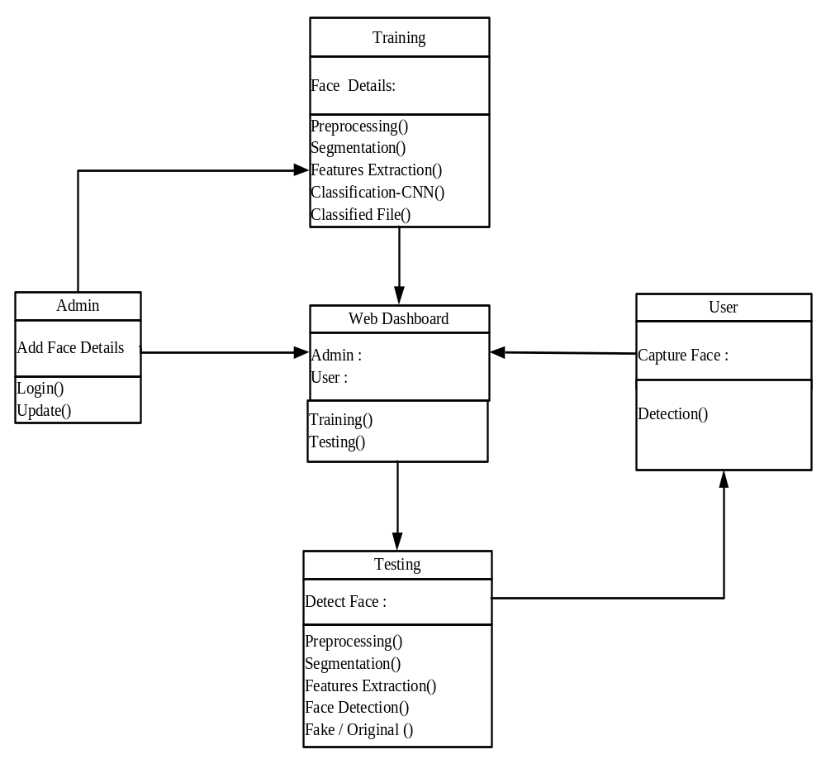

5. PROJECT DESCRIPTION

5.1 MODULES

- Data Collection and Preprocessing
- Feature Extraction
- Training Deep Learning Model
- Model Evaluation
- Forgery Detection

  - MODULES DESCRIPTION

- Data Collection and Preprocessing
This module involves gathering a diverse dataset of authentic and manipulated images. Preprocessing techniques such as resizing, normalization, and augmentation are applied to prepare the data for training the deep learning model. This module focuses on the crucial task of gathering a diverse dataset comprising both authentic and manipulated images.
The process begins with the collection of authentic images, which represent genuine, unaltered photographs. These images are sourced from various sources, including public databases, online repositories, or proprietary datasets, ensuring a broad representation of real-world scenarios.
Additionally, manipulated images, which have been digitally altered or edited, are curated to provide examples of common tampering techniques such as cloning, splicing, or retouching.
- Feature Extraction
In this module, features are extracted from the images to represent their characteristics. Deep learning models, such as convolutional neural networks (CNNs), are used to automatically learn and extract relevant features from the images.
In this module, the process of feature extraction from images is explored, aiming to represent their distinctive characteristics effectively. Deep learning techniques, particularly convolutional neural networks (CNNs), are employed to automate and optimize this feature extraction process.
Convolutional neural networks (CNNs) have revolutionized the field of image processing due to their ability to learn complex features directly from raw pixel data. Unlike traditional handcrafted feature extraction methods, which require extensive domain knowledge and manual tuning, CNNs can automatically learn hierarchical representations of features from the input images.
At the core of CNNs are convolutional layers, which apply a set of learnable filters (also known as kernels) to the input image, capturing different patterns and features. These filters slide across the image, performing convolution operations to extract features at various spatial locations.

- Training Deep Learning Model
The extracted features are used to train a deep learning model for forgery detection. This module involves selecting an appropriate architecture (e.g., CNN, recurrent neural network (RNN), etc.) and optimizing the model parameters using labeled training data.
The process of utilizing extracted features to train a deep learning model for forgery detection is a crucial component of many modern security systems, particularly in fields such as document authentication, image forensics, and multimedia content verification.
This module involves several key steps aimed at developing a robust and accurate model capable of effectively detecting forgeries within digital content.
Firstly, the extracted features serve as essential inputs to the deep learning model. These features are typically derived from various aspects of the digital content under scrutiny, such as texture, color distribution, spatial patterns, or frequency domain representations.

- Model Evaluation
This module assesses the performance of the trained deep learning model using evaluation metrics such as accuracy, precision, recall, and F1-score. The model is tested on a separate validation or test dataset to measure its generalization ability. The assessment module plays a critical role in gauging the efficacy and generalization capability of the trained deep learning model. Through the utilization of evaluation metrics such as accuracy, precision, recall, and F1-score, this module provides comprehensive insights into the model's performance across various dimensions.
Precision measures the proportion of true positive predictions among all positive predictions made by the model. It highlights the model's ability to minimize false positive instances, emphasizing precision as a crucial metric in scenarios where false positives can have significant consequences.

- Forgery Detection
Once the model is trained and evaluated, it is used to detect digital image forgeries in unseen data. The model examines the input images and predicts whether they are authentic or manipulated based on learned patterns and features. It scrutinizes various aspects of the images, such as pixel values, color distributions, texture patterns, and structural inconsistencies.
The model’s ability to detect digital image forgeries relies on its capacity to generalize learned features to unseen data effectively. Through extensive training on diverse datasets containing both authentic images and various forms of manipulation, the model hones its ability to differentiate between genuine and altered content. This process enables the model to adapt and evolve, becoming increasingly adept at identifying sophisticated manipulation techniques.

- IMPLEMENTATION

6.1 ALGORITHM AND TECHNIQUES:

6.1.1 CONVOLUTIONAL NEURAL NETWORK:

The implementation of a Convolutional Neural Network (CNN) for a multifaceted synthetic media authentication and deception detection framework, specifically for deepfake face detection, involves multiple stages, including data preprocessing, network architecture design, training, and evaluation. The first step is data acquisition and preprocessing, where a dataset containing authentic and deepfake face images is collected from various sources such as Face Forensics++, Celeb-DF, or custom-generated datasets using generative adversarial networks (GANs).
The images undergo preprocessing steps including resizing, normalization, and data augmentation techniques such as rotation, flipping, and contrast adjustments to enhance the model’s generalization capability. Additionally, to improve robustness, frequency domain analysis techniques like Discrete Cosine Transform (DCT) or Discrete Wavelet Transform (DWT) can be incorporated to capture subtle artifacts present in synthetic images that might not be visible in the spatial domain.
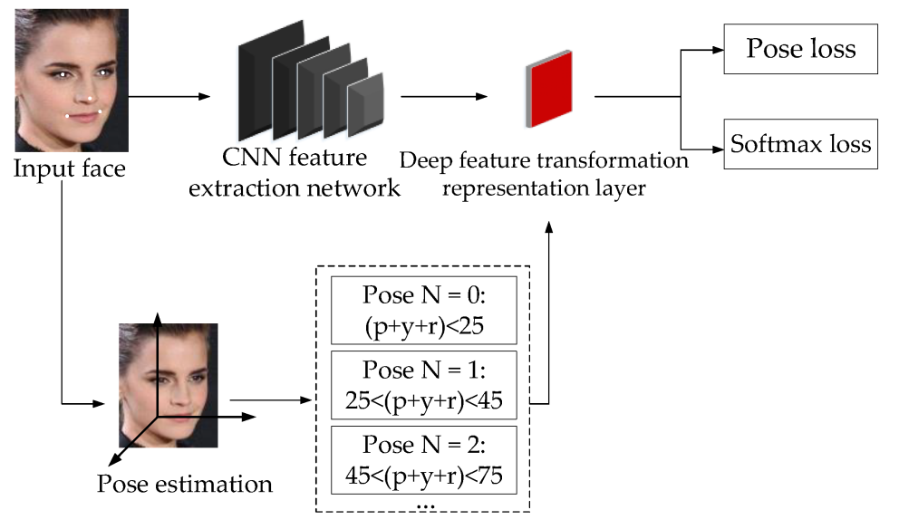
Once the dataset is prepared, the CNN architecture is designed with layers optimized for feature extraction and classification. A typical deepfake detection CNN model consists of convolutional layers, batch normalization, activation functions (ReLU), pooling layers, dropout layers, and fully connected layers. The convolutional layers are responsible for extracting spatial features such as texture inconsistencies, color distortions, and blending artifacts often introduced by deepfake generation techniques. Feature maps obtained from convolutional layers are passed through pooling layers to reduce dimensionality while preserving important patterns.
To improve stability and avoid overfitting, dropout layers and batch normalization are employed. The final layers of the network consist of fully connected layers with a softmax activation function that outputs the probability score for classification into real or fake categories.
The training process involves feeding the CNN model with labeled data and optimizing it using backpropagation and an appropriate optimizer such as Adam or SGD. A loss function like binary cross-entropy is used to quantify the classification error, and techniques like learning rate scheduling and early stopping are applied to enhance convergence.
Transfer learning is also employed by fine-tuning pre-trained models like Xception, EfficientNet, or ResNet, which have been proven effective in deepfake detection tasks due to their ability to capture intricate facial representations. Furthermore, attention mechanisms such as the spatial attention module or channel attention module can be integrated to highlight regions that contain significant deepfake artifacts, further improving detection performance.
During inference, the trained CNN model processes unseen face images and outputs a classification probability indicating whether the image is real or fake. Post-processing techniques such as ensemble learning, where multiple CNN models’ predictions are aggregated, can be used to further refine detection accuracy. Additionally, integrating explainability methods such as Grad-CAM (Gradient-weighted Class Activation Mapping) helps interpret the model’s decision by visualizing important regions that contribute to classification.
The effectiveness of the CNN-based detection framework is continuously evaluated using metrics such as accuracy, precision, recall, F1-score, and ROC-AUC, ensuring high reliability in identifying deepfake content and preventing digital deception.

Convolutional Neural Networks (CNNs)

CNNs are a specialized type of neural network designed for processing grid-like data, such as images and videos. They leverage convolutional layers to apply filters to input data, capturing spatial hierarchies of features.
CNNs have revolutionized computer vision tasks, achieving remarkable accuracy in image classification, object detection, and segmentation. Applications of CNNs span diverse domains, including autonomous vehicles, medical imaging, and surveillance systems.

Recurrent Neural Networks (RNNs)

RNNs are another class of neural networks designed to process sequential data, such as time series and natural language. Unlike feedforward neural networks, RNNs incorporate recurrent connections that enable them to retain memory of previous inputs, making them well-suited for tasks requiring temporal dependencies.
Applications of RNNs include speech recognition, language translation, and sentiment analysis.

Generative Adversarial Networks (GANs)

GANs are a class of deep learning models introduced by Ian Goodfellow and colleagues in 2014. GANs consist of two neural networks – a generator and a discriminator – trained simultaneously in a competitive fashion. The generator synthesizes new data samples, while the discriminator distinguishes between real and fake samples.

Transfer Learning

Transfer learning is a technique in deep learning where a model trained on one task is fine-tuned for a related task with limited data. Pre-trained models, such as those trained on large-scale image datasets like ImageNet, serve as starting points for transfer learning.
By leveraging knowledge learned from a source task, transfer learning enables faster convergence and improved performance on target tasks with smaller datasets.

Hardware Acceleration

The computational demands of deep learning models have led to the development of specialized hardware accelerators optimized for neural network computations. Graphics processing units (GPUs) have emerged as the workhorse of deep learning, offering parallel processing capabilities that accelerate training and inference tasks.

Reinforcement Learning (RL)

RL is a branch of machine learning concerned with learning sequential decision-making policies through interaction with an environment. In RL, an agent learns to maximize cumulative rewards by taking actions in an environment and receiving feedback in the form of rewards or penalties.
Deep reinforcement learning combines deep neural networks with RL algorithm to learn complex policies from high-dimensional sensory inputs. Deep RL has achieved groundbreaking results in challenging domains, such as game playing, robotics, and autonomous system.

- SYSTEM TESTING

7.1 SYSTEM TESTING

Software testing is a structured process that ensures the reliability and efficiency of a software application before its deployment. Testing is a systematic activity that starts at the module level and extends to the integration of the entire computer-based system. It plays a critical role in ensuring the success and quality of software. Without thorough testing, software may fail to meet performance expectations, leading to defects and operational issues.

Testing Objectives: The primary objectives of software testing are:
- Testing is conducted to execute a program with the intent of finding errors.
- A well-designed test case has a high probability of uncovering previously undiscovered errors.
- A successful test is one that identifies an error not previously detected.
If testing is conducted effectively based on these objectives, it helps uncover errors in the software and ensures that it functions according to the given specifications.

If testing is conducted effectively based on these objectives, it helps uncover error in the software and ensures that it functions according to the given specifications.

There are three key ways to test a program:
- For Correctness: Ensuring that a program performs its intended functionality accurately.
- For Implementation Efficiency: Optimizing program execution to make it faster or use fewer resources.
- For Computational Complexity: Evaluating the complexity of algorithms and comparing different solutions.

  - TYPES OF TESTING

    - UNIT TESTING:
Unit testing is the first step in the software testing process. The software source code is typically divided into modules, which are further broken down into smaller units. Each unit performs a specific function and requires individual testing.
The process of validating these small units is known as unit testing. The goal is to ensure that each component of the system functions correctly as per documented specifications. Unit testing varies based on the programming language used for development.
It helps in detecting bugs early, improving software quality, and ensuring that every unit is working as expected. In an engineering environment, unit testing ensures the reliability of individual components before they are integrated into the entire system.

7.2.2 FUNCTIONAL TESTING :
Functional testing evaluates a system to verify whether it performs the intended functions as outlined in its specifications. This type of testing ensures that various software modules work together correctly and meet the requirements. The primary objectives include:

1. Finding defects by testing two or more modules together.
2. Confirming that no defects exist in the integrated modules.
3. Verifying that each module performs its intended function.
4. Establishing confidence that the program operates as expected.

Functional testing plays a vital role in assessing the accuracy and completeness of a software system. It helps identify any inconsistencies and ensures that the application functions as intended in real-world scenarios.
7.2.3 INTEGRATION TESTING:
Integration testing focuses on verifying interactions between different software modules. Once individual modules have passed unit testing, they are combined and tested as a group. The goal is to detect interface defects and issues that may arise when multiple modules interact. Integration testing typically follows unit testing and is conducted before system testing.
This testing approach is particularly useful in large-scale software systems where multiple modules interact with external applications, databases, and network components. Beta testing, often used for software products, falls under integration testing as it allows real users to evaluate the software before its final release.

  - TEST RESULTS:
All test cases mentioned above were executed successfully. No defects were encountered during the testing process, and the software demonstrated expected behavior in all scenarios. By following a systematic testing approach, the software met its specified requirements and was ready for deployment.

8. CONCLUSION AND FUTURE ENHANCEMENT

8.1 CONCLUSION
The proliferation of image manipulation poses significant challenges to the authenticity and integrity of faces, eroding trust in their reliability. Motivated primarily by the desire to deceive and obfuscate, image forgery has become increasingly sophisticated, rendering manipulated images indistinguishable to the naked eye. This trend has particularly grave implications for crime investigation, where the veracity of digital evidence is paramount. In response to these challenges, this paper presents a novel approach to enhance digital face forgery detection using advanced deep learning techniques, specifically via transfer learning. By leveraging transfer learning, our proposed technique aims to simultaneously uncover two types of image forgery, providing a comprehensive solution to address the evolving landscape of image manipulation. Central to our approach is the identification of discrepancies in compressed quality within the image, a hallmark of forged areas that typically deviate from the compression patterns observed in authentic regions. By harnessing deep learning algorithms, we empower our system to discern these subtle but crucial differences, enabling it to accurately detect instances of face forgery with unprecedented precision. The proposed technique holds immense promise in bolstering the trustworthiness of digital images and fortifying the integrity of digital evidence in various domains, including crime investigation, journalism, and content moderation.

8.2 FUTURE ENHANCEMENT
Digital face forgery detection will focus on improving the adaptability and robustness of deep learning models to counter increasingly sophisticated manipulation techniques. One promising direction is the integration of multimodal analysis, combining visual, audio, and temporal cues to detect deepfake videos with greater accuracy. Real-time detection systems powered by lightweight and efficient architectures will also be crucial for deployment in forensic investigations and online content moderation.

9. BIBILIOGRAPHY

BOOK REFERENCES

1. X. Pan, ``Research and implementation of access control system based on RFID and FNN-face recognition,'' in Proc. 2nd Int. Conf. Intell. Syst. Design Eng. Appl., Jan. 2012, pp. 716-719, doi: 10.1109/ISdea.2012.400.
2. Li, S. Shan, andW. Gao, ``Coupled bias-variance tradeoff for cross-pose face recognition,'' IEEE Trans. Image Process., vol. 21, no. 1, pp. 305-315, Jan. 2012.
3. H. S. Bhatt, S. Bharadwaj, R. Singh, and M.Vatsa, ``Recognizing surgically altered face images using multi objective evolutionary algorithm,'' IEEE Trans. Inf. Forensics Security, vol. 8, no. 1, pp. 89-100, Jan. 2013.
4. Taleb, M. E. Amine Ouis, and M. O. Mammar, ``Access control using automated face recognition: Based on the PCA & LDA algorithms,'' in Proc. 4th Int. Symp. ISKO-Maghreb, Concepts Tools Knowl. Manage. (ISKO- Maghreb), Nov. 2014, pp. 1-5.
5. Ding, C. Xu, and D. Tao, ``Multi-task pose-invariant face recognition,'' IEEE Trans. Image Process., vol. 24, no. 3, pp. 980-993, Mar. 2015.

WEBSITE REFERENCES

- https://ieeexplore.ieee.org/document/6173306
- https://ieeexplore.ieee.org/document/5936114
- https://ieeexplore.ieee.org/document/6327663
- https://ieeexplore.ieee.org/document/7033455
- https://ieeexplore.ieee.org/abstract/document/7006757
APPENDICES

SAMPLE CODING

from flask import Flask, render_template, flash, request, session,send_file
from flask import render_template, redirect, url_for, request
#from wtforms import Form, TextField, TextAreaField, validators, StringField, SubmitField
from werkzeug.utils import secure_filename
import datetime
import mysql.connector
import sys
import tensorflow as tf
import numpy as np
from tkinter import *
import os
from tkinter import filedialog
import cv2
import time
from matplotlib import pyplot as plt
from tkinter import messagebox
app = Flask(__name__)
app.config['DEBUG']
app.config['SECRET_KEY'] = '7d441f27d441f27567d441f2b6176a'
@app.route("/")
def homepage():
return render_template('index.html')
@app.route("/AdminLogin")
def AdminLogin():
return render_template('AdminLogin.html')
@app.route("/tdataset")
def tdataset():
return render_template('tdataset.html')
@app.route("/train")
def train():
import ResNet
return "Train SuccessFull"
@app.route("/AdminHome")
def AdminHome():
conn = mysql.connector.connect(user='root', password='', host='localhost', database='1leafdb')
cursor = conn.cursor()
cursor.execute("SELECT * from regtb")
data = cursor.fetchall()
return render_template('AdminHome.html',data=data)
@app.route("/adminlogin", methods=['GET', 'POST'])
def adminlogin():
if request.method == 'POST':
username = request.form['uname']
password = request.form['password']
session['uname'] = request.form['uname']
conn = mysql.connector.connect(user='root', password='', host='localhost', database='1leafdb')
cursor = conn.cursor()
cursor.execute("SELECT * from admin where username='" + username + "' and Password='" + password + "'")
data = cursor.fetchone()
if data is None:
alert = 'Username or Password is wrong'
return render_template('goback.html', data=alert)
else:
conn = mysql.connector.connect(user='root', password='', host='localhost', database='1leafdb')
cursor = conn.cursor()
cursor.execute("SELECT * from regtb")
data = cursor.fetchall()
return render_template('AdminHome.html',data=data)
@app.route("/UserLogin")
def UserLogin():
return render_template('UserLogin.html')
@app.route("/NewUser")
def NewUser():
return render_template('NewUser.html')
@app.route("/UserHome")
def UserHome():
user = session['uname']
conn = mysql.connector.connect(user='root', password='', host='localhost', database='1leafdb')
# cursor = conn.cursor()
cur = conn.cursor()
cur.execute("SELECT * FROM regtb where username='" + user + "'")
data = cur.fetchall()
return render_template('UserHome.html',data=data)
@app.route("/userlogin", methods=['GET', 'POST'])
def userlogin():
if request.method == 'POST':
username = request.form['uname']
password = request.form['password']
session['uname'] = request.form['uname']
conn = mysql.connector.connect(user='root', password='', host='localhost', database='1leafdb')
cursor = conn.cursor()
cursor.execute("SELECT * from regtb where username='" + username + "' and Password='" + password + "'")
data = cursor.fetchone()
if data is None:
alert = 'Username or Password is wrong'
return render_template('goback.html', data=alert)
else:
return render_template('UserHome.html')
@app.route("/newuser", methods=['GET', 'POST'])
def newuser():
if request.method == 'POST':
name1 = request.form['name']
gender1 = request.form['gender']
Age = request.form['age']
email = request.form['email']
pnumber = request.form['phone']
address = request.form['address']
uname = request.form['uname']
password = request.form['psw']
conn = mysql.connector.connect(user='root', password='', host='localhost', database='1leafdb')
cursor = conn.cursor()
cursor.execute(
"INSERT INTO regtb VALUES ('" + name1 + "','" + gender1 + "','" + Age + "','" + email + "','" + pnumber + "','" + address + "','" + uname + "','" + password + "')")
conn.commit()
conn.close()
# return 'file register successfully'
return render_template('UserLogin.html')
@app.route("/result", methods=['GET', 'POST'])
def result():
if request.method == 'POST':
f = request.files['file']
txt =f.filename
x1 = txt.split("_")
f.filename = "test.jpg"
#f.save(secure_filename(f.filename))
f.save("static/upload/" + secure_filename(f.filename))
filename = 'Output/Out/Test.jpg'
f.save("static/"+secure_filename(f.filename))
from tensorflow.keras.layers import Input, Lambda, Dense, Flatten
from tensorflow.keras.models import Model
from tensorflow.keras.applications.resnet50 import ResNet50, preprocess_input
from tensorflow.keras.preprocessing import image
from tensorflow.keras.preprocessing.image import ImageDataGenerator, load_img
from tensorflow.keras.models import Sequential
import scipy
import numpy as np
from glob import glob
import matplotlib.pyplot as plt
# Paths
train_Path = 'train'
test_Path = 'test'
# Set Resize variable
IMAGE_SIZE = [224, 224] # This is my desired image size... and also ResNet50 accepts image of 224*224.
from tensorflow.keras.models import load_model
model = load_model('model.h5')
model.summary()
img = image.load_img('static/upload/test.jpg', target_size=IMAGE_SIZE)
x = image.img_to_array(img)
print(x)
print(x.shape)
x = x / 255
x = np.expand_dims(x, axis=0)
img_data = preprocess_input(x)
x.shape, img_data.shape
s = model.predict(img_data)
# pred = np.argmax(model.predict(input_arr_img))
print(s)
a = np.argmax(model.predict(img_data), axis=1)
print(a)
classes_dir = ["Fake", "Real"]
# Loading Image
# img = image.load_img(path,target_size=(224, 224))
# Normalizing Image
norm_img = image.img_to_array(img) / 255
# Converting Image to Numpy Array
input_arr_img = np.array([norm_img])
# Getting Predictions
pred = np.argmax(model.predict(input_arr_img))
# Printing Model Prediction
print(classes_dir[pred])
return render_template('result.html', data1=classes_dir[pred],data=str(x1[0]))
if __name__ == '__main__':
app.run(debug=True, use_reloader=True)
# Part 1 - Building the CNN
# Importing the Keras libraries and packages
from keras.models import Sequential
from keras.layers import Convolution2D
from keras.layers import MaxPooling2D
from keras.layers import Flatten
from keras.layers import Dense
from keras.models import model_from_json
import matplotlib.pyplot as plt
import warnings
warnings.filterwarnings('ignore')
batch_size = 32
from tensorflow.keras.preprocessing.image import ImageDataGenerator
# All images will be rescaled by 1./255
train_datagen = ImageDataGenerator(rescale= 1 /255)
# Flow training images in batches of 128 using train_datagen generator
train_generator = train_datagen.flow_from_directory(
'Dataset/Train', # This is the source directory for training images
target_size=(200, 200), # All images will be resized to 200 x 200
batch_size=batch_size,
# Specify the classes explicitly
classes = ['Fake' ,'Real'],
# Since we use categorical_crossentropy loss, we need categorical labels
class_mode='categorical')
import tensorflow as tf
model = tf.keras.models.Sequential([
# Note the input shape is the desired size of the image 200x 200 with 3 bytes color
# The first convolution
tf.keras.layers.Conv2D(16, (3 ,3), activation='relu', input_shape=(200, 200, 3)),
tf.keras.layers.MaxPooling2D(2, 2),
# The second convolution
tf.keras.layers.Conv2D(32, (3 ,3), activation='relu'),
tf.keras.layers.MaxPooling2D(2 ,2),
# The third convolution
tf.keras.layers.Conv2D(64, (3 ,3), activation='relu'),
tf.keras.layers.MaxPooling2D(2 ,2),
# The fourth convolution
tf.keras.layers.Conv2D(64, (3 ,3), activation='relu'),
tf.keras.layers.MaxPooling2D(2 ,2),
# The fifth convolution
tf.keras.layers.Conv2D(64, (3 ,3), activation='relu'),
tf.keras.layers.MaxPooling2D(2 ,2),
# Flatten the results to feed into a dense layer
tf.keras.layers.Flatten(),
# 128 neuron in the fully-connected layer
tf.keras.layers.Dense(128, activation='relu'),
# 5 output neurons for 5 classes with the softmax activation
tf.keras.layers.Dense(2, activation='softmax')
])
model.summary()
from tensorflow.keras.optimizers import RMSprop
early = tf.keras.callbacks.EarlyStopping(monitor='val_loss' ,patience=5)
model.compile(loss='categorical_crossentropy',
optimizer=RMSprop(lr=0.001),
metrics=['accuracy'])
total_sample =train_generator.n
n_epochs = 10
history = model.fit_generator(
train_generator,
steps_per_epoch=int(total_sample /batch_size),
epochs=n_epochs,
verbose=1)
model.save('model1.h5')
acc = history.history['accuracy']
loss = history.history['loss']
epochs = range(1, len(acc) + 1)
# Train and validation accuracy
plt.plot(epochs, acc, 'b', label=' accurarcy')
plt.title(' accurarcy')
plt.legend()
plt.figure()
# Train and validation loss
plt.plot(epochs, loss, 'b', label=' loss')
plt.title(' loss')
plt.legend()
plt.show()
import matplotlib.pyplot as plt
import numpy as np
from sklearn.metrics import classification_report, confusion_matrix, ConfusionMatrixDisplay
labels = ["Fake", "Real"]
print(labels)
y_true = np.random.randint(low=0, high=2, size=100, dtype=int)
print(y_true)
classesIndexes, classesFrequency = np.unique(y_true, return_counts=True)
print('classes indexes:', classesIndexes)
print('\n')
print('classes frequency:', classesFrequency)
plt.rcParams['figure.figsize'] = (10.0, 7.0)
figure = plt.figure()
plt.bar(classesIndexes, classesFrequency, align='center', alpha=0.6)
plt.ylabel('Class frequency', fontsize=16)
# Giving names to every Bar along X axis
plt.xticks(classesIndexes, labels, fontsize=16)
# Giving name to the plot
plt.title('Histogram', fontsize=20)
# Saving the plot
figure.savefig('histogram.png', transparent=True, dpi=500)
# Showing the plot
plt.show()
# Making copy of array with True classes' indexes
y_predicted = np.copy(y_true)
# Choosing randomly 25% of classes to be changed
ii = np.random.randint(low=0, high=len(y_true), size=int(0.25 * len(y_true)), dtype=int)
# Check point
# Showing chosen indexes
print(ii)
# Iterating chosen indexes and replacing them with other classes' indexes
for i in ii:
# Generating new class index
y_predicted[i] = np.random.randint(low=0, high=2, dtype=int)
# Check point
# Showing difference between True classes' indexes and Predicted ones
print('index = {0:2d}, True class => {1}, {2} <= Predicted class'.
format(i, y_true[i], y_predicted[i]))
# Confusion Matrix is a two dimensional matrix that visualizes the performance,
# and makes it easy to see confusion between classes,
# by providing a picture of interrelation
# Each row represents a number of actual, True class
# Each column represents a number of predicted class
# Computing Confusion Matrix to evaluate accuracy of classification
c_m = confusion_matrix(y_true, y_predicted)
# Showing Confusion Matrix in form of 2D Numpy array
print(c_m)
# Magic function that renders the figure in a jupyter notebook
# instead of displaying a figure object
# %matplotlib inline
# Setting default size of the plot
# Setting default fontsize used in the plot
plt.rcParams['figure.figsize'] = (10.0, 9.0)
plt.rcParams['font.size'] = 20
# Implementing visualization of Confusion Matrix
display_c_m = ConfusionMatrixDisplay(c_m, display_labels=labels)
# Plotting Confusion Matrix
# Setting colour map to be used
display_c_m.plot(cmap='OrRd', xticks_rotation=4)
# Other possible options for colour map are:
# 'autumn_r', 'Blues', 'cool', 'Greens', 'Greys', 'PuRd', 'copper_r'
# Setting fontsize for xticks and yticks
plt.xticks(fontsize=15)
plt.yticks(fontsize=15)
# Giving name to the plot
plt.title('Confusion Matrix', fontsize=24)
# Saving plot
plt.savefig('confusion_matrix.png', transparent=True, dpi=500)
# Showing the plot
plt.show()
# Showing the main classification metrics
print(classification_report(y_true, y_predicted))
# Importing needed libraries

SAMPLE SCREENS

